|  |  |
| --- | --- |
| **Assignment Case** |  |
| CPEN6098 | CPEN6108 | CPEN6109 | CPEN6098001  Computer Networks |
| **Computer Engineering** | **O223-CPEN6098-IX07-02** |
| ***Valid on*** *Odd Semester Year 2021/2022* | **Revision 00** |

1. Seluruh mahasiswa tidak diperkenankan untuk:

*All students are not allowed to:*

* + - Berdiskusi dan/atau bekerja sama dengan mahasiswa lainnya

*Discuss and/or work together with other student participants*

* + - Melihat sebagian atau seluruh jawaban mahasiswa lain

*Seeing a part or the whole answer from another student*

* + - Membuka dan menyalin dari **BUKU** atau **CATATAN**, **VIDEO** dari pengajar (recording kelas, VBL, Youtube, dsb) dan **REFERENSI** lainnya

*Open and copy from any resources such as notes, videos (class recording, VBL, Youtube, etc) and other references*

* + - Membuka dan menyalin jawaban dari internet (google, stackoverflow, dsb)

*Open and copy answer from the internet (google, stackoverflow, etc)*

* + - Mengerjakan soal yang tidak sesuai dengan tema yang ada di soal,

*Working with another theme which is not in accordance with the existing theme in the matter of the case,*

* + - Melakukan tindakan kecurangan lainnya,

*Committing other dishonest actions,*

* + - Secara sengaja maupun tidak sengaja melakukan segala tindakan kelalaian yang menyebabkan hasil karyanya berhasil dicontek oleh orang lain / kelompok lain.

*Accidentally or intentionally conduct any failure action that cause the results of the project was copied by someone else / other groups.*

1. Jika mahasiswa terbukti melakukan tindakan seperti yang dijelaskan butir 1 di atas, maka **nilai mahasiswa** yang melakukan kecurangan (menyontek maupun dicontek) akan di – **NOL** – kan.

*If the student is proved to the actions described in point 1 above, the score of the student which committed dishonest acts (cheating or being cheated) will be “Zero”*

1. Perhatikan jadwal pengumpulan jawaban, segala jenis pengumpulan jawaban di luar jadwal tidak dilayani.

*Pay attention to the submission schedule, all kinds of submission outside the schedule will not be accepted*

1. Bila Anda tidak membaca peraturan ini, maka Anda dianggap telah membaca dan menyetujuinya

*If you have missed to read these regulations, so you are considered to have read and agreed on it*

1. Persentase penilaiaan untuk matakuliah ini adalah sebagai berikut:

*Marking percentage for this subject is described as follows:*

|  |  |  |
| --- | --- | --- |
| **Tugas Mandiri**  *Assignment* | **Proyek**  *Project* | **UAP**  *Final Exam* |
| 100% | - | - |

1. Software yang digunakan pada matakuliah ini adalah sebagai berikut:

*Software will be used in this subject are described as follows:*

|  |
| --- |
| **Software**  *Software* |
| Cisco Packet Tracer 7.3.0  WinBox 3.24  VMware Workstation 15  VM MikroTik 6.45.9 |

## Ekstensi file yang harus disertakan dalam pengumpulan tugas mandiri untuk matakuliah ini adalah sebagai berikut:

*File extensions should be included in assignment collection for this subject are described as follows:*

|  |  |  |
| --- | --- | --- |
| **Tugas Mandiri**  *Assignment* | **Proyek**  *Project* | **UAP**  *Final Exam* |
| DOCX, PKA | - | - |

## Soal

*Case*

1. Lulus Company wants to build a new network. You are requested to use **VLAN**. **Open** the “**Case** **01**.**pka**” file and follow the instructions shown in the case. Make sure that **every PC in the same division is connected to each other**, **and not connected to the PC of other division**.

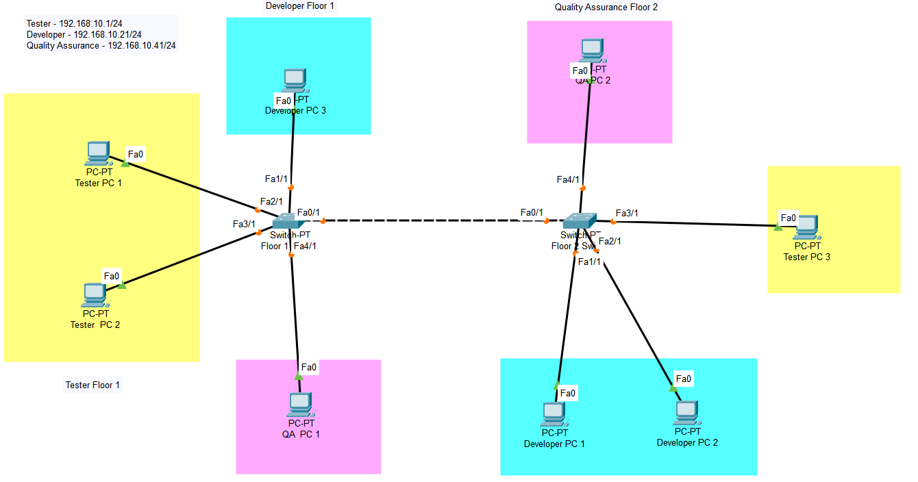

1. The picture on below shows the **WLAN** which is requested by Lulus Company for it’s new branch office. Open the “**Case** **02**.**pka**” file and follow the instructions shown in the case. All **computers must be able to send and receive packet from other computers**.

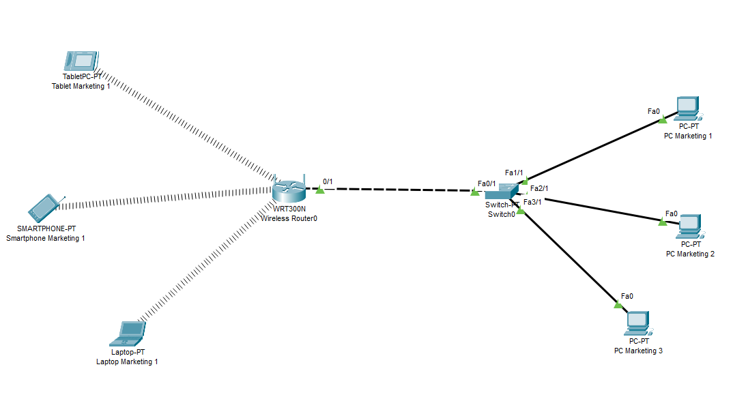

1. The picture on below shows the **LAN** which is requested by Lulus Company. **Open** **the** “**Case** **03**.**pka**” file and follow the instructions shown in the case.

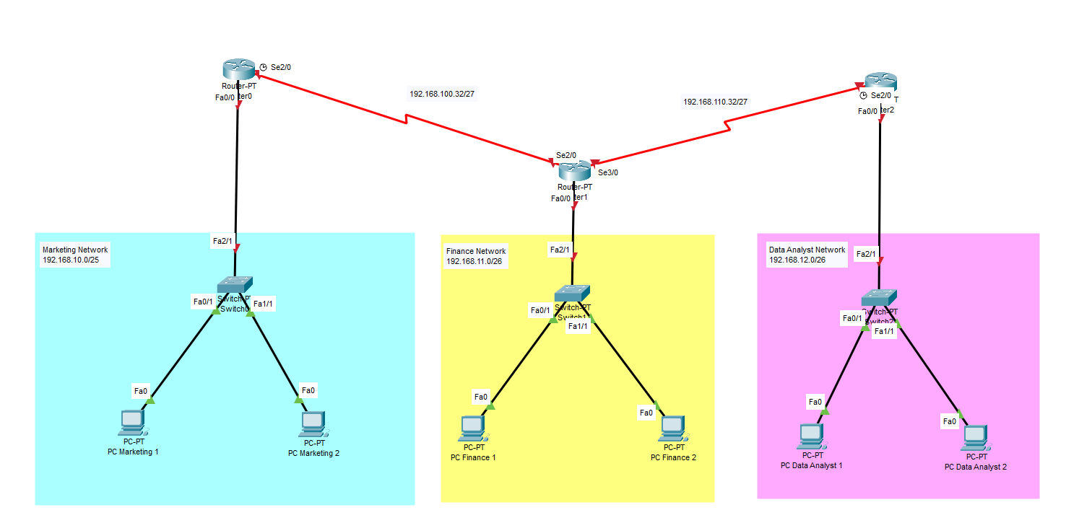

1. The picture on below shows the **LAN** which is requested by Lulus Company. **Open** **the** “**Case** **04**.**pka**” file and follow the instructions shown in the case.

